# Sensor Layer

## General

The Sensor Layer allows the system to communicate with the sensors. The installed sensors will provide information about triggered events to the central layer which will then pass the information on to the Control Layer, or central computer.

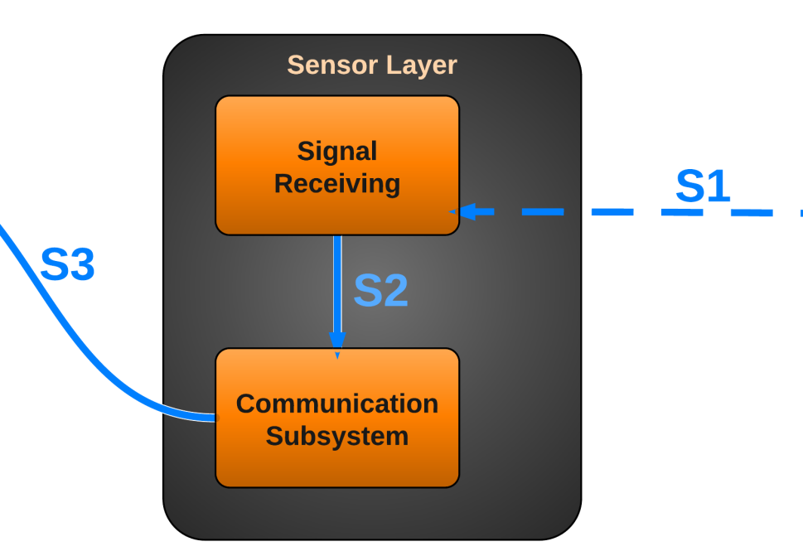

Figure 4 - Sensor Layer

## Subsystems

### Signal Receiving

#### General

The Signal Receiving subsystem is software running on a microcontroller that receives status changes of the sensors. The subsystem will then simply pass on this information to the communication subsystem.

#### Assumptions

The microcontroller must be powered on and working properly.

#### Responsibilities

The Signal Receiving subsystem is responsible for detecting changes in the state of the sensors, indicating an event that must be passed on to the communication subsystem.

#### Subsystem Inter-layer Interfaces

N/A

#### Subsystem Public Interfaces

N/A

#### Inputs

Sensor Data: The current state of the sensors is continuously supplied to this subsystem. The subsystem does not do any significant calculation until a change in sensor state is noticed.

#### Outputs

Signal Status Changed: The Signal Receiving subsystem determines which of the sensors has been triggered by the usage of the microcontroller’s functionality.

### Communication Subsystem

#### General

The Communication Subsystem communicates with the Control Layer (Central Computer) through the usage of a serial communication line, informing the Control Layer of which sensor has been triggered.

#### Assumptions

All networking hardware is configured and working correctly.

#### Responsibilities

The Communication Subsystem receives which sensor has been triggered and sends this information along to the Control Layer via means of a serial communication line.

#### Subsystem Inter-layer Interfaces

N/A

#### Subsystem Public Interfaces

N/A

#### Inputs

Signal Status Changed: The specific sensor ID is passed in, indicating which sensor has been triggered.

#### Outputs

Signal Status Changed: The specific sensor ID representing which sensor has been changed is communicated to the Control Layer.

# Camera Layer

## General

The Camera Layer allows the system to communicate with the camera. The system will be able to retrieve the video and audio feeds from the camera, and send positioning commands (Pan/Tilt) to the camera. The Camera Layer will only accept communications from a secure, authenticated, and authorized source.

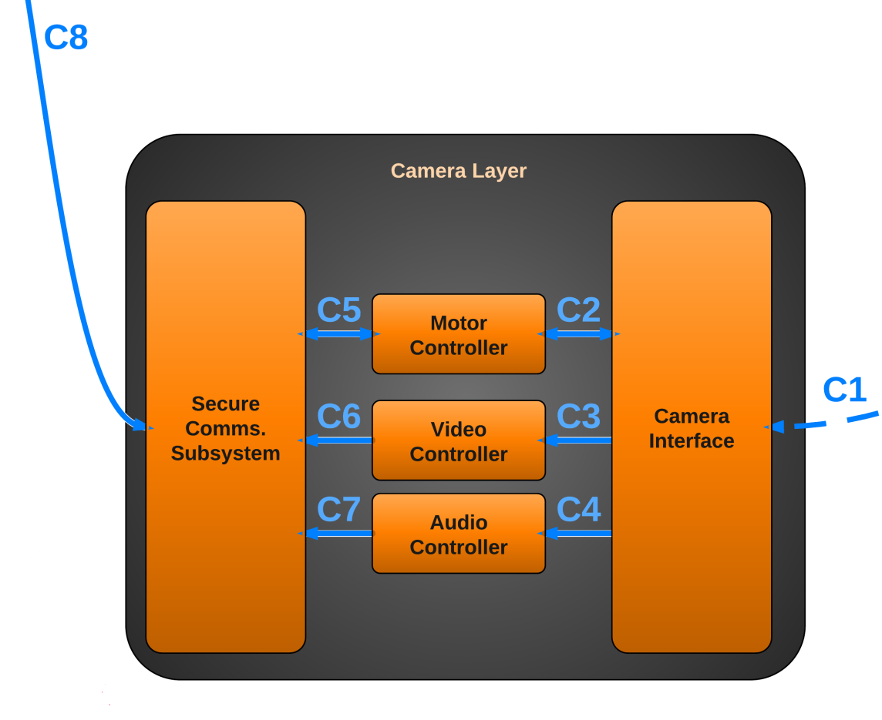

Figure 5 - Camera Layer

## Subsystems

### Camera Interface

#### General

The Camera Interface subsystem is software running on the Central Computer that actually communicates with the camera hardware. The subsystem will process all commands, such as those used to retrieve audio and video streams, and commands to control the position of the camera.

#### Assumptions

The Central Computer must be powered on, and the MAVS Systems software must be running on the computer.

#### Responsibilities

The Camera Interface subsystem is responsible for all communications between the camera hardware and the rest of the system. This allows the system to retrieve audio and video data, and instruct the camera to change its position.

#### Subsystem Inter-layer Interfaces

N/A

#### Subsystem Public Interfaces

N/A

#### Inputs

Camera Location/Orientation: The current location/orientation of the camera is supplied to the Camera Interface by the camera.

Video Data: The current video feed is supplied to the Camera Interface by the camera.

Audio Data: The current audio feed is supplied to the Camera Interface by the camera.

#### Outputs

Camera Location/Orientation: The Camera Interface subsystem provides the Motor Controller subsystem with the camera’s current position and orientation.

Video Data: The Camera Interface subsystem provides the Video Controller subsystem with the current video feed from the camera.

Audio Data: The Camera Interface subsystem provides the Audio Controller subsystem with the current audio feed from the camera.

### Motor Controller Subsystem

#### General

The Motor Controller Subsystem communicates with the Secure Comms. Subsystem to receive movement commands from the user for the camera. This allows the user to be able to instruct the camera to pan or tilt. Additionally, the Motor Controller Subsystem communicates with the Camera Interface to instruct the camera hardware to change its position and orientation.

#### Assumptions

All networking hardware is configured and working correctly. The Central Computer must be powered on, and the MAVS Systems software must be running on the computer. Additionally, the camera is powered on and working correctly.

#### Responsibilities

The Motor Control Subsystem is responsible for receiving movement commands from the Secure Comms. Subsystem and relaying those commands to the Camera Interface.

#### Subsystem Inter-layer Interfaces

N/A

#### Subsystem Public Interfaces

N/A

#### Inputs

Camera Position/Orientation: A new desired camera position/orientation is supplied to the Motor Controller Subsystem.

#### Outputs

Camera Position/Orientation: The desired camera position/orientation is passed to the Camera Interface, which can then instruct the camera hardware to move.

### Video Controller Subsystem

#### General

The Video Controller Subsystem communicates with the Secure Comms. Subsystem to return the current video stream of the camera to the user. Additionally, the Video Controller Subsystem communicates with the Camera Interface to instruct the camera to provide its video feed data. This subsystem also provides the capability to transform the video data into different formats based on current settings.

#### Assumptions

All networking hardware is configured and working correctly. The Central Computer must be powered on, and the MAVS Systems software must be running on the computer. Additionally, the camera is powered on and working correctly.

#### Responsibilities

The Video Controller Subsystem is responsible for retrieving the video feed data from the Camera Interface. Additionally, if necessary, the subsystem is responsible for transforming the video data into a different format as needed (for example, to a lower resolution).

#### Subsystem Inter-layer Interfaces

|  |  |  |  |
| --- | --- | --- | --- |
| *Method* | *Description* | *Information Required* | *Information Returned* |
| GetVideoFeed | The raw video data is received from the Camera Interface and is collected into a temporary buffer. | Video Feed Data | Raw Video Data buffer |
| TransformVideoFeed | The raw video data is converted into a format that the user desires. For example, the resolution may be lowered to conserve bandwidth. | Raw Video Data buffer, Video Format Settings | New Raw Video Data buffer |

#### Subsystem Public Interfaces

N/A

#### Inputs

Raw Video Data: The camera’s raw video data of the current feed is provided to the Video Controller Subsystem.

#### Outputs

Transformed Raw Video Data: The (optionally) transformed video data is provided to the Secure Comms. Subsystem.

### Audio Controller Subsystem

#### General

The Audio Controller Subsystem communicates with the Secure Comms. Subsystem to return the current audio stream of the camera to the user. Additionally, the Audio Controller Subsystem communicates with the Camera Interface to instruct the camera to provide its audio feed data.

#### Assumptions

All networking hardware is configured and working correctly. The Central Computer must be powered on, and the MAVS Systems software must be running on the computer. Additionally, the camera is powered on and working correctly. The camera is capable of recording audio data.

#### Responsibilities

The Audio Controller Subsystem is responsible for retrieving the audio feed data from the Camera Interface.

#### Subsystem Inter-layer Interfaces

N/A

#### Subsystem Public Interfaces

N/A

#### Inputs

Raw Audio Data: The camera’s raw audio data of the current feed is provided to the Audio Controller Subsystem.

#### Outputs

Raw Audio Data: The audio data is provided to the Secure Comms. Subsystem.

### Secure Communications Subsystem

#### General

The Secure Communications Subsystem communicates with the Secure Communications. Subsystem in the Control Layer to return the current audio and video streams of the camera to the user and to provide the current position/orientation of the camera. Additionally, the Secure Communications Subsystem relays new position change requests to the Motor Controller Subsystem in order to move the camera.

#### Assumptions

All networking hardware is configured and working correctly. The Central Computer must be powered on, and the MAVS Systems software must be running on the computer. Additionally, the camera is powered on and working correctly.

#### Responsibilities

The Secure Communications Subsystem is responsible for communicating with the Secure Communications Subsystem of the Control Layer, providing it with the current audio and video streams and the current camera position and orientation.

#### Subsystem Inter-layer Interfaces

N/A

#### Subsystem Public Interfaces

N/A

#### Inputs

(Transformed) Raw Video Data: The camera’s (optionally) transformed raw video data of the current feed is provided to the subsystem.

Raw Audio Data: The camera’s raw audio data of the current feed is provided to the subsystem.

Camera Position/Orientation: The camera’s position and orientation is provided to the subsystem.

#### Outputs

(Transformed) Raw Video Data: The camera’s (optionally) transformed raw video data of the current feed is communicated to the Secure Communications Subsystem of the Control Layer.

Raw Audio Data: The camera’s raw audio data of the current feed is communicated to the Secure Communications Subsystem of the Control Layer.

Camera Position/Orientation: The camera’s position and orientation is communicated to the Secure Communications Subsystem of the Control Layer.